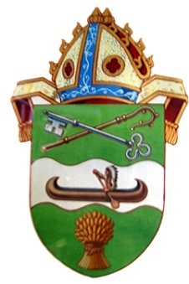
The Right Reverend Michael W. Hawkins Bishop of Saskatchewan
The Right Reverend Adam S. Halkett Bishop of Missinipi
1308 Fifth Avenue East Prince Albert Saskatchewan S6V 2H7 (306) 763-2455

July 15th, 2016

Dear sisters and brothers

We write to you at the conclusion of General Synod 2016. We thank God for your many prayers, for us, for our delegates and for the Synod. It was a difficult, confusing and exhausting experience and we want you to know how well represented you were by Mrs. Caron Hallen, Ms. Jasohna Haukenfrers, Dr. John Rye, the Rev. Gethin Edward and the Rev. Chris Dow. It is hard to imagine a more heartbreaking and confusing outcome of General Synod for all.

The Synod voted in favour of changing the Marriage Canon to include same sex couples but to come into effect there needs to be another similar two thirds majority vote in 2019. We regret that the Synod decided to remove the protection of the consciences of dioceses, congregations and clergy who could not perform or accommodate same sex marriages. In the next three years the Anglican Church of Canada will need to find a way forward that allows for the integrity and flourishing of both those in favour of and those opposed to this change within its fellowship but there was little evidence of a desire for that at the Synod.

We also regret the lack of real and sensitive consultation with indigenous elders. This is a misstep in our commitment to walk together and to support in word and example the principles of The United Nations Declaration on the Rights of Indigenous Peoples.

Many within our Diocese and across the Anglican Church of Canada have threatened to ‘leave’ depending on the decision one way or another. While we would not want to underestimate the seriousness of our differences and the crisis that will be caused as some bishops proceed with same sex marriages without the authorization of General Synod and contrary to the doctrine and discipline of the Church, we cannot deny that those who confess the Lordship of Christ, proclaim the Creed and have been baptized with water in the Trinity are our sisters and brothers. Even, or rather especially, in the midst of these difficulties and divisions, we are called to live out the truth, one Lord, one Faith, one Baptism. We belong to each other and we need each other in Christ.

We call all to love and prayer, especially for and towards those with whom we disagree whether in our Parish or Diocese or the Anglican Church of Canada as we seek to find a way to peaceably coexist.

Law and judgment lead to death but our message is love and forgiveness to all and for all which lead to life. While we are committed to upholding the scriptural, catholic and traditional definition of marriage, we are also committed to working to make our Diocese and its Congregations places of welcome and healing for all.

In Christ,
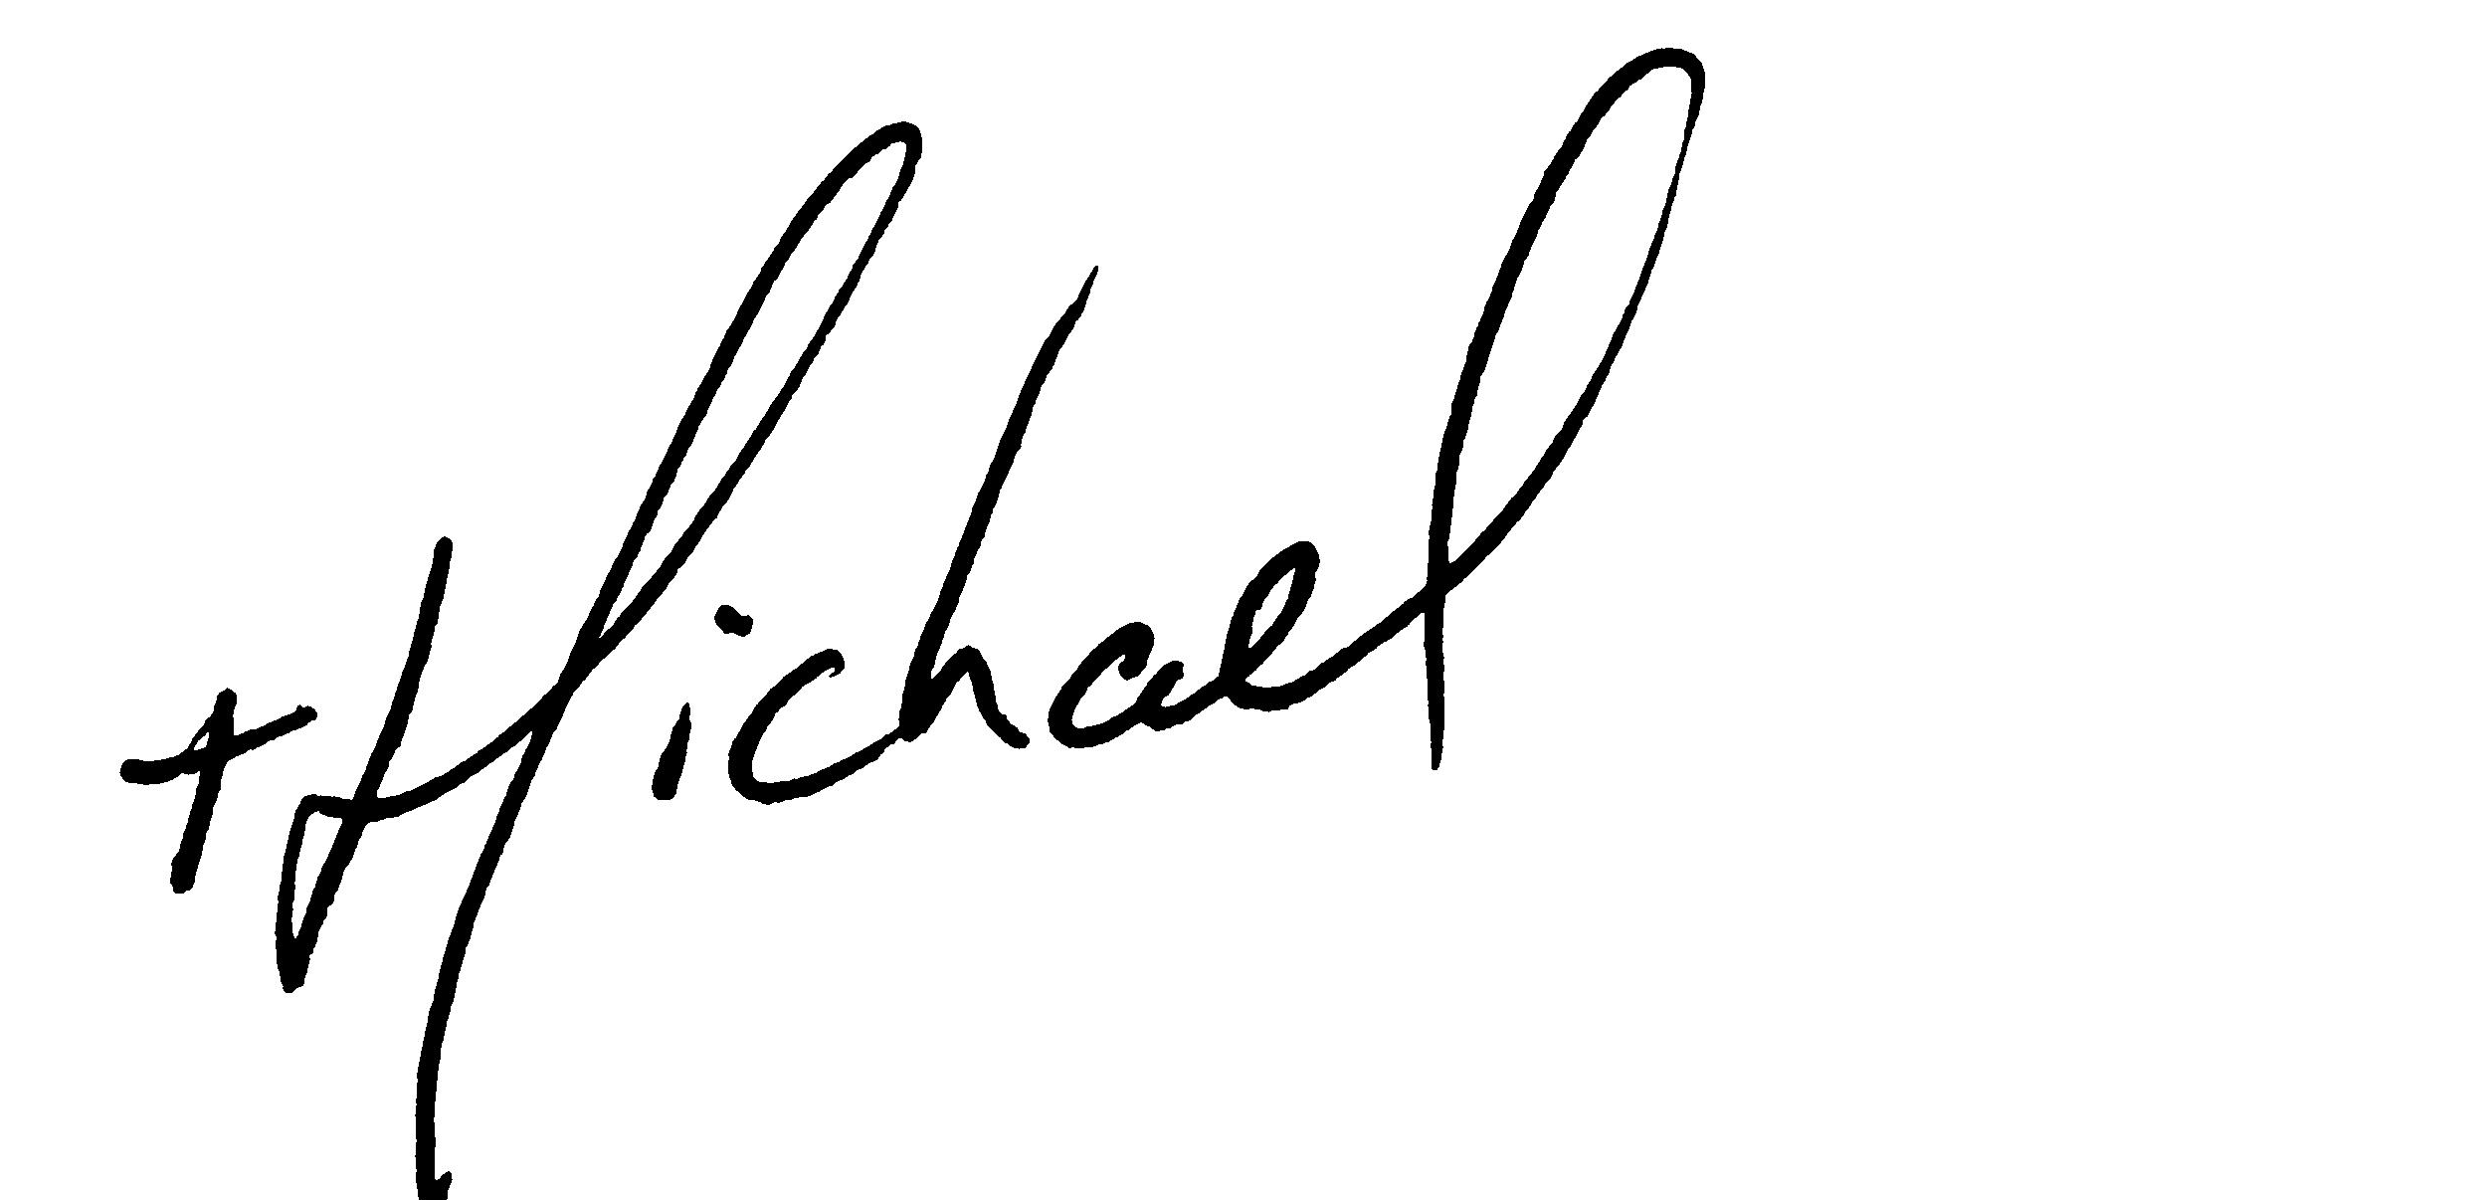
Michael W. Hawkins Adam S. Halkett

