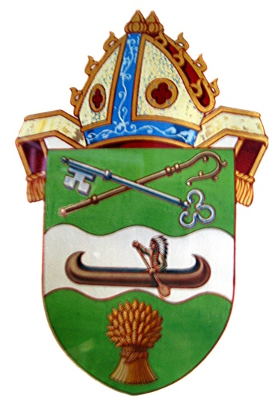
The Diocese of Saskatchewan
NEW LOCATION:
1410 Bishop McLean Cres.
St. Alban’s Cathedral
We are Open
Monday –Thursday
9am-12 and 1-4pm

Please use WEST (white) door
(Hall lower level)

Mailing address:
PO Box 23125
Prince Albert SK
S6V 8A7

Phone: (306) 763-2455 Email: synod@sasktel.net

