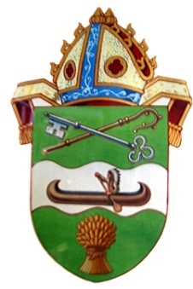

The Right Reverend Michael W. Hawkins Bishop of Saskatchewan
The Right Reverend Adam S. Halkett
Bishop of Missinipi
Diocese of Saskatchewan PO Box 23125 Prince Albert SK S6V 8A7
(306) 763-2455

Pray and Wash your hands
Diocese of Saskatchewan March 12th 2020
COVID 19 Church and Holy Communion
The coronavirus we are now facing causes an infection in the nose, throat and lungs. Coronavioruses are shared by coughing, sneezing, touching, shaking hands, and contact with infected surfaces. All of us should be frequent and thorough with our hand washing, especially at this time, and avoid touching our face, eyes, mouth and nose.
In response to the increased risk and fears we are issuing the following directives
- Hand sanitizers must be available in more than one location in every Church.
- Those who are ill with a communicable disease should be encouraged to stay home.
- All those leading in worship must wash their hands thoroughly before every service.
- All those administering communion must use hand sanitizer or wash their hands again at the offertory and must completely avoid touching their face, eyes, nose, and mouth.
- A clean purificator must be used for each chalice at each service and wiped with friction on the rim after each communicant receives.
- Communion vessels must be cleansed with hot soapy water before each service.
- Fears around the transmission of disease and the use of the Common Cup are unfounded (see
https://www.anglican.ca/pir/euc-practice-infection)
but those who are sick with a communicable disease or who are particularly vulnerable should consider receiving in only one kind. The Church has always taught that the grace of the Eucharist is available in its fullness in either kind. Receiving in one kind (the consecrated host only) is a reasonable precaution for those who think they might have an infectious disease or those whose immune system is compromised.
- Intinction is a most dangerous practice, infecting the chalice for all. Effective immediately and as a precaution for all, intinction by the communicant is no longer possible. Those who should not or cannot receive communion from the common cup should receive in one kind only.
- Communicants should touch the base of the Chalice/Cup ONLY and never touch the bowl or rim.
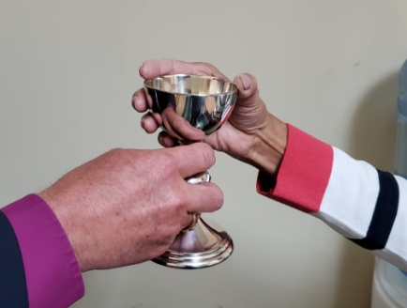

- While some are already avoiding handshaking, we are not prepared to require this until we have further notice from competent authorities.
- We commend to your prayers all those who are affected by this disease, those grieving, those who are living and working in fear, those who are in isolation, those battling this disease on so many fronts and those caring for the sick and dying.
- Our direction is simple.
Wash your hands and Pray.

